**A MINI PROJECT REPORT**

***Submitted by:***

**BUNITA WANGKHEM**

**23MCA20556**

in

MASTER OF COMPUTER APPLICATIONS (MCA)

***under the supervision of***

**Dr. Javed Alam**



**University Institute of Computing, Chandigarh University, India.**

**November, 2024**

Table of Contents

Business Summary Dashboard 4

1. Project Overview 4

2. Objectives 4

3.DATASET REQUIREMENT:

4. DASHBOARD COMPONENTS

3.1 Key Metrics 5

3.2 Visualizations 6

3.3 Interactivity 7

5. STEPS FOR DASHBOARD CREATION

5.1 Data Preparation 7

5.2 Setting Up PivotTables 8

5.3 Creating Visualizations 8

6. Conclusion 8

7. Future Enhancements 8

8. Detail of Project uploaded on Github 9

**AIM:**

**Create a dashboard to analyze and visualize sales data to monitor performance**

**metrics such as revenue, profit margin and sales by region.**

**OBJECTIVE:**

Develop an interactive dashboard in Excel to analyze and visualize sales data. The dashboard will monitor critical performance metrics, including revenue, profit margin, and sales by region, to support data-driven decision-making.

**PROJECT OVERVIEW:**

* Purpose: To create a comprehensive sales performance dashboard that will help stakeholders quickly assess sales trends, regional performance, and profitability.
* Goals:
* Analyze sales data by revenue, profit margin, and region. o Visualize key metrics with dynamic charts and tables.
* Make the dashboard interactive and user-friendly.

**DATASET REQUIREMENT:**

• Data Fields:

* Date: To analyze trends over time and group by month.
* Region: To assess performance by different geographical areas. o Product: To evaluate individual product performance. o Revenue: To monitor sales income.
* Cost: To calculate profit and profit margins.
* Profit: Derived as (Revenue - Cost).
* Data Source: Sample sales data for various products across multiple regions, organized by month and year.

**DASHBOARD COMPONENTS**

* Key Metrics:

o Total Revenue: Overall income from sales. o Total Profit: Net income (Revenue - Cost). o Profit Margin: Percentage of revenue retained as profit. o Units Sold by Product and Region: Sales quantity breakdown.

• Visualizations:

* Revenue by Region: A bar chart showing regional performance. o Profit Margin by Region: A bar chart or gauge visualizing profitability by region. o Monthly Revenue Trends: Line chart displaying revenue over time.
* Units Sold by Product: Bar chart for product-level analysis.

• Interactivity:

* Slicers: Filters for Region and Product to allow for targeted analysis.
* Date Grouping: Monthly and yearly grouping for trend analysis.

**STEPS FOR DASHBOARD CREATION**

1. Data Preparation:

o Import or enter the dataset into Excel. o Clean and format data, ensuring dates are in a usable format. o Add calculated fields for Profit and Profit Margin as necessary.

2. Setting Up PivotTables:

* Revenue by Region PivotTable: Summarize revenue for each region. o Profit Margin by Region PivotTable: Calculate and display profit margin by region. o Monthly Revenue Trends PivotTable: Group by month to identify seasonal trends.
* Units Sold by Product PivotTable: Analyze sales quantity by product.
  1. Creating Visualizations: o Insert appropriate charts for each PivotTable, such as bar charts for regions and products, and a line chart for monthly revenue trends.
* Format charts with clear labels, titles, and color schemes for easy readability.
  1. Adding Interactivity: o Insert slicers for Region and Product in each relevant PivotTable.
* Ensure slicers are aligned and connected to their respective PivotTables.

5. Dashboard Layout and Design:

* Arrange charts and tables to create a cohesive layout on a single worksheet. o Use consistent formatting and colors to improve readability and aesthetics.
* Label each section clearly and provide a title for the dashboard.

**TIMELINE**

* Day 1: Data collection and preparation.
* Day 2: Set up and format PivotTables.
* Day 3: Create charts and set up slicers for interactivity.
* Day 4: Design and arrange the dashboard layout.
* Day 5: Final review and testing.

**OUTPUT:**

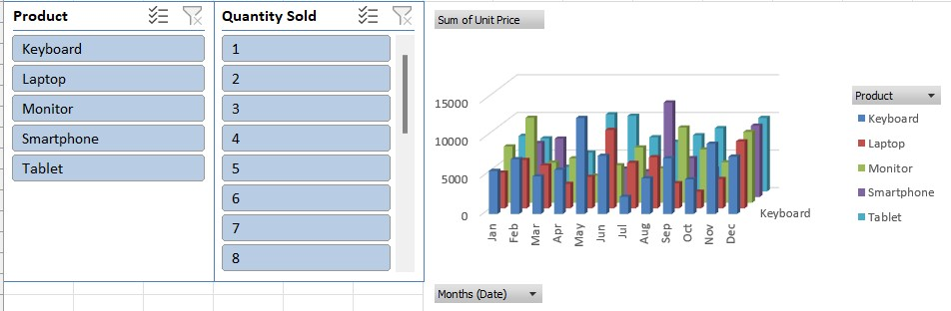

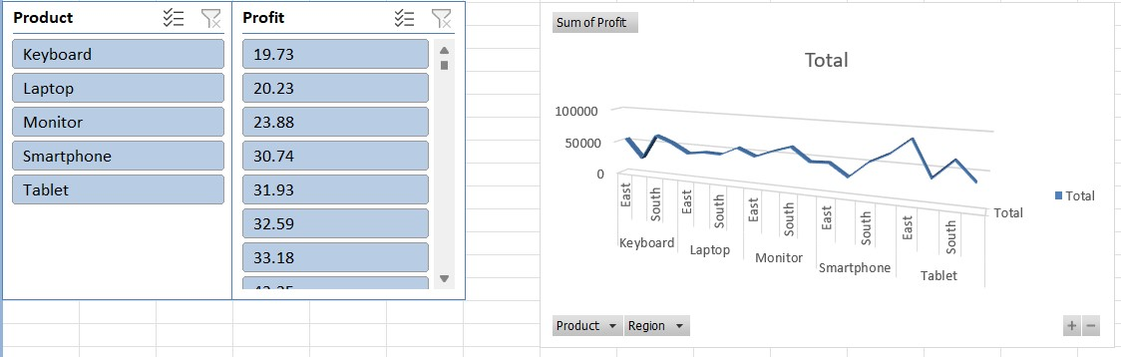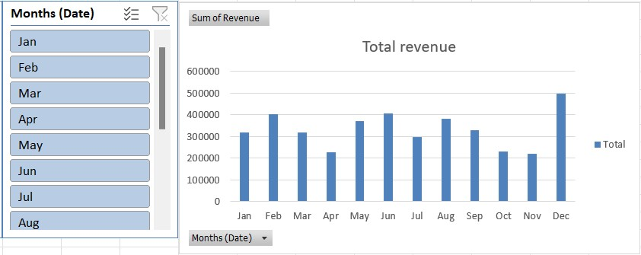

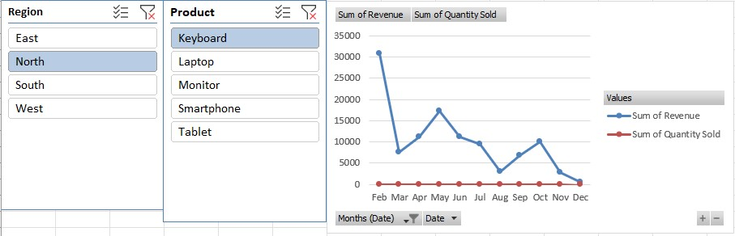

### **6.** Project Conclusion

The sales dashboard provides a comprehensive view of key performance metrics, allowing stakeholders to track revenue, profit margin, and regional sales effectively. By consolidating and visualizing sales data in one place, this dashboard enables quick insights into overall business performance and empowers data-driven decision-making.

Key takeaways include:

1. **Revenue and Profit Trends**: The dashboard enables monthly tracking of revenue and profit margins, helping identify high-performing products and regions. This insight allows for targeted efforts to increase profitability by focusing on high-margin products and top-performing regions.
2. **Regional Sales Analysis**: Comparing sales across regions has highlighted geographic areas with strong sales growth, as well as those with potential for improvement. By identifying these trends, the company can allocate resources more effectively to maximize growth.
3. **Salesperson Performance**: Tracking sales at the individual salesperson level provides insights into team performance and aids in recognizing top achievers, as well as identifying areas for coaching and support.
4. **Real-time Decision Support**: The dashboard’s interactive nature enables leaders to drill down into specific metrics or periods, allowing for proactive responses to emerging trends. This real-time visibility facilitates better planning and operational adjustments.

### 7.Future Enhancements

To enhance the dashboard, consider adding more granular data, such as customer demographics or product categories, and introducing forecasting models. Integrating data from other business units, such as marketing, could also provide a more holistic view of performance drivers.